There is an infrastructure of n cities with some number of roads connecting these cities. Each roads[i] = [ai, bi] indicates that there is a bidirectional road between cities ai and bi.

The **network rank**of **two different cities** is defined as the total number of **directly** connected roads to **either** city. If a road is directly connected to both cities, it is only counted **once**.

The **maximal network rank**of the infrastructure is the **maximum network rank** of all pairs of different cities.

Given the integer n and the array roads, return *the****maximal network rank****of the entire infrastructure*.

**Example 1:**

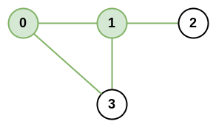

**Input:** n = 4, roads = [[0,1],[0,3],[1,2],[1,3]]

**Output:** 4

**Explanation:** The network rank of cities 0 and 1 is 4 as there are 4 roads that are connected to either 0 or 1. The road between 0 and 1 is only counted once.

**Example 2:**

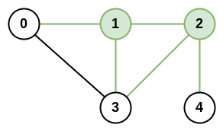

**Input:** n = 5, roads = [[0,1],[0,3],[1,2],[1,3],[2,3],[2,4]]

**Output:** 5

**Explanation:** There are 5 roads that are connected to cities 1 or 2.

**Example 3:**

**Input:** n = 8, roads = [[0,1],[1,2],[2,3],[2,4],[5,6],[5,7]]

**Output:** 5

**Explanation:** The network rank of 2 and 5 is 5. Notice that all the cities do not have to be connected.

**Constraints:**

* 2 <= n <= 100
* 0 <= roads.length <= n * (n - 1) / 2
* roads[i].length == 2
* 0 <= ai, bi <= n-1
* ai != bi
* Each pair of cities has **at most one** road connecting them.